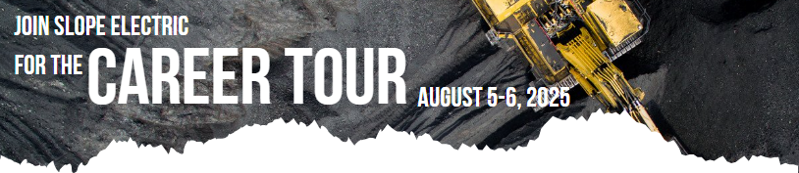

Application Form
Student Information:
Full Name:
Date of Birth: |  |  | Grade level  During the 2025-2026 school year:
School Name:
Address:
City: |  |  | State:
Zip: |  |  | Phone Number:
Email Address:
Do you have dietary restrictions or special accommodation?
Parent/Guardian Information:
Full Name:
Relationship to Applicant:
Phone Number: |  |  | Email Address:
Are you a member of Slope Electric?*
Emergency Contact:
Full Name:
Relationship to Applicant: |  | Phone Number:
Question: This question is a required part of your applications. Please provide a response of no more than 300 words briefly explaining why you are interested in participating in the Slope Electric Youth Career Tour.

Parent/Guardian Consent:
I, [Parent/Guardian Name], give consent for my child, [Applicant Name], to participate in the North Dakota Youth Career Tour. I understand that the tour may involve visits to various locations and activities related to the energy industry.
Applicant Signature: __________________________________ Date: ________________________
Parent/Guardian Signature: ____________________________ Date: ________________________
*Cooperative membership is not a requirement for eligibility.

